## ART WEB GALLERY



##### A PROJECT REPORT SUBMITTED TO ALHAMD ISLAMIC UNIVERSITY IN PARTIAL FULFILMENT OF THE REQUIREMENTS FOR THE DEGREE OF BS IN COMPUTER SCIENCE

**BY**

**NAME**

**BSCS-1825215004**

**DEPARTMENT OF COMPUTER SCIENCE**

**ALHAMD ISLAMIC UNIVERSITY, MULTAN**

**2021**

**CERTIFICATE**

The thesis is to be submitted to the Department of Computer Science and Engineering, Alhamd Islamic University, Multan for the partial fulfillment of the requirement for the Bachelor’s degree in Computer Science.

##### Dr. ------------

##### Supervisor

##### Date:

**Dr. -----------**

**Co-Supervisor**

**Date:**

**Verified By**

**Prof. Dr. -------**

**Chairperson**

**Department of Computer Science**

**Controller of Examination Date:**

**DECLARATION**

I declare that the work contained in this thesis is my own, except where explicitly stated otherwise. In addition this work has not been submitted to obtain another degree or professional qualification.

##### ACKNOWLEDGEMENTS

I would like to show my heartfelt gratitude to Allah Almighty for giving me stability and ability to finish this report.

I would never have to be able to complete my thesis without the enlightenment of my group members, assistance of my friends and encouragement from my family.

I might want to express gratitude towards my advisor Dr. Amjad Farooq, who calmly rectified my writing and monetarily upheld my research. I might likewise want to express my gratitude towards Dr. Amjad Farooq for directing my research for as long as quite a while and helping me to build up my experience in developing web application. Exceptional much gratitude goes to Dr. Amjad Farooq, who was willing to take an interest in my last defense committee. I would like to offer my most profound thanks to my Co-advisor, Mr. Samyan Wahla, for his brilliant direction, mindful, tolerance, and furnishing me with an incredible environment for doing research.

I might likewise want to thank my parents. They were continually supporting and empowering me to do better. They were consistently there brightening me up and remained by my side through the various difficulties.

**CONTENTS**

#### Title

#### Certificate

Declaration

Acknowledgements Abstract

##### Chapter 1: Introduction

Introduction

Objectives

Functional Requirements

Non Functional Requirements

##### Chapter 2 Requirement Specifications

System Requirements

Hardware Requirements

Software Requirements

##### Chapter 3 System Analysis

Existing System

Proposed System

System Analysis

System Life Cycle

Feasibility Study

Economic Feasibility

Technical Feasibility

Operational Feasibility

##### 

##### Chapter 4 System Design

Data Flow Diagram

Activity Diagram

Use Case Diagram

Sequence Diagram

Interface Diagram

**Conclusion**

**References**

#### Page No.

v

vii

viii

1

3

3

3

4

4

5

5

6

9

9

13

13

13

15

14

17

17

18

19

17

18

19

20

21

35

36

**ABSTRACT**

The main focus of this project is to design a novel art web gallery that is very helpful for the art lovers and others who wants to buy the arts. The entire system runs on the internet. The system has been written in HTML, CSS, Bootstrap, JavaScript, and PHP. User can sign in from any spot with an internet connection. From that point forward, they can do various tasks designed for them. Users are classified into three groups: (admin, artist and client). The essential objective is to focus on each client who can get art works. This application helps the end-users to view the arts and paintings and they can place an order for the selected pieces. The art web gallery is updated daily, so the client can view and buy the latest collection of contemporary art online from anywhere in the world. The database stores all information about the artist products, client’s orders, client’s payments, artist payments and client’s feedback. This system is valuable and more helpful for everybody.

**CHAPTER – 1**

**INTRODUCTION TO THE STUDY**

**Introduction**

Art web gallery is a web based application that is used to display and promote art works of artist regardless of their nationality, gender and other narrow consideration. The purpose of this is to reach art works every corner of world by using technology. Artist can sign up online for being a member in the art gallery and every artist can add their art work under the respective categories. They can host their art work. The artist is susceptible to pay a fraction of the price of each art work to the web site to find the running fund for site. Art enthusiasts ought to visit the art exhibition to accumulate their favored arts or painting. But now-a-days they're now no longer getting sufficient time to visit the galleries and accumulate the arts and paintings. This system helps the client to view, select and purchase art work within their comfort zone.

##### Objectives

The objectives of developing the art web gallery are as follows:

* To store all the information of entire user who are registered in the system.
* To resolve the problems of user in time efficient manner.
* Online updating of all kinds of art, updating records using web based interfaces and with the help of buttons and links in an easy and efficient way.
* Data security is maintained to relatively high level by implementing it at database level, so as to ensure that only authorized users have access to confidential user information.
* Developing a system that retrieve the information accurately and efficiently.
* Easy registration
* Login dependent information retrieval and updating. Correct and consistent maintenance of data and its quick retrieval.
* Help the clients to view and receive the purchased art works directly from artist.

**Functional Requirements**

The entire project mainly consists of 3 modules, which are

* Admin module
* Client module
* Artist module

**Admin Module**

* Admin can login to the system.
* Admin can manage allocation requests.
* Admin can manage artists.
* Admin can manage clients.
* Admin can view all the products uploaded by artist.
* Admin can view artist payments.
* Admin can view client payments.
* Admin can view the client’s feedback.
* Admin can logout.

**Artist Module**

* Artist can register into the system.
* Artist can login to the system.
* Artist can generate space allocation request.
* Artist can view the space allocation request.
* Artist can manage the products.
* Artist can make payments.
* Artist can manage orders.
* Artist can view the payment details.
* Artist can logout.

**Client Module**

* Client can register into the system.
* Client can login to the system.
* Client can view the products.
* Client can add products to cart.
* Client can confirm the order.
* Client can make payments either through credit card, debit card or cash on delivery.
* Client can search and view the artists.
* Client can send feedback.
* Client can view the feedback.
* Client can logout.

**Non-Functional Requirements**

### Performance

1. Average load time of the web page must be less than five seconds.
2. System response time must be less than 10 seconds.
3. Our system should easily accessible on the system having minimal internet speed of 1MB per second.

### Supportability

All code might be written as specified by the Hungarian Naming Convention.

### Security

### All the information of users should be secure and user should be able to access only necessary information.

# CHAPTER – 2

**REQUIREMENT SPECIFICATIONS**

### System Requirements

To be used efficiently, all computer software requires certain hardware components or other software resources that reside on a computer. These requirements are known as system requirements and are often used as a guideline rather than an absolute rule of thumb. Most software defines two types of system requirements: minimum requirements and recommended system requirements. With the increasing demand for more computing power and resources in newer software versions, the system requirements increase over time. Industry analysts believe this trend will play a bigger role in updating existing computer systems than technological advancement.

**Hardware Requirements**

The most common requirements defined by an operating system or software application are the computer's physical resources, also known as hardware. A list of hardware requirements is often accompanied by a Hardware Compatibility List, especially for operating systems. HCL Lists tested, compatible, and sometimes incompatible hardware devices for a specific application or operating system.

The hardware requirements for our project are:

Processor : Intel dual Core, i5

RAM : 8 GB

Hard disk : 80 GB

**Software Requirements**

Software requirements define the software resource requirements and requirements that must be installed on a computer in order for an application to run optimally. These requirements or prerequisites are generally not included in the software installation package and must be installed separately before installing the software.

The software requirements for our project are:

Operating System : Windows 10

Front end : HTML, CSS, JavaScript

Server side script : PHP

Database : MySQL

**HTML**

HTML, or Hypertext Markup Language, is the standard markup language used to create web pages. It is written in the form of HTML elements made up of tags enclosed in angle brackets i.e. <html>. It describes the structure of a website semantically along with hints on how to display what makes it a markup language and not a programming language.

HTML elements are the building blocks of all websites. HTML enables images and objects to be embedded and can be used to create interactive forms. It provides a way to create structured documents by specifying the structural semantics of text such as headings, paragraphs, lists, links, quotation marks, and other elements. It enables us to embed scripts written in languages ​​such as JavaScript that affect the behavior of HTML web pages.

**Cascading Style sheets (CSS)**

CSS is a stylesheet language used to describe the appearance of a document written in a markup language. Although the language is most commonly used for designing web pages and interfaces written in HTML and XHTML, it can be applied to any type of XML document, including pure XML, SVG, and XUL. CSS is a basic specification of the web and almost all web pages use CSS stylesheets to describe their appearance. CSS was primarily developed to enable the separation of document content from the presentation document, including elements such as layout, colors, and fonts. This separation can improve content accessibility, provide more flexibility and control in specifying presentation characteristics, allow formatting of multiple pages together, and reduce the complexity and repetition of structural content. CSS can also allow the same markup page to be rendered in different styles for different rendering methods, such as on-screen, in print, by voice (when reading in a browser or voice-based screen reader), and on touch devices as well to allow the web page to be displayed differently depending on the screen. While the author of a document generally associates this document with a CSS file, readers can use a different stylesheet, possibly one on their own computer, to override this, the author indicated. If the author or reader has not associated the document with a specific style sheet, the default browser style will be applied.

**JavaScript**

JavaScript is the scripting language of the web. All modern HTML pages use JavaScript. A scripting language is a lightweight programming language. JavaScript code can be inserted into any HTML page and executed by all types of web browsers. .JavaScript is easy to learn.

**PHP**

PHP is an acronym for Hypertext Preprocessor which is a widely-used, open source scripting language. It is used to manage dynamic content, databases, session tracking, and even create entire e-commerce sites. It is integrated with a number of popular databases, including MySQL, PostgreSQL, Oracle, Sybase, Informix, and Microsoft SQL Server.

**MySQL**

MySQL is developed, distributed and supported by Oracle Corporation. MySQL is a database system that is used on the web and runs on a server. MySQL is ideal for small and large applications. It's very fast, reliable, and easy to use. It supports standard SQL. MySQL can be compiled on different platforms. Data in MySQL is stored in tables. A table is a collection of related data and consists of columns and rows. Databases are useful for categorizing information.

# CHAPTER – 3

### SYSTEM ANALYSIS

##### Existing System

Customer can also register online and they can browse art works that are arranged in different categories scientifically. Each Customer can create their own gallery to see his favorite art works without much difficult. And each user has the right to purchase an art work using the integrated payment gateway and participate in auction by submitting their bids. Qualified bidder should remit the amount using payment gateway and after each valid payment the art work will be shipped within some days.

##### Proposed System

Art gallery is a web application software and it is very helpful for the art lovers and others who wants to know the addresses where this kind of arts will we sold.

This application helps the end-users to search their arts and paintings and they can place order for the selected pieces. The end-user can also get the information about the art exhibition and the respective address, so, that they can visit to those exhibitions.

Art Gallery brings you an opportunity to view online art exhibitions at our art web gallery we bring you details of all art exhibitions held in the past and the forthcoming show. The Online Art Gallery is updated daily, so the user can view and buy the latest collection of contemporary art online from anywhere in the world. You can view and buy the latest Indian contemporary art collection available at their exhibitions and also at their online gallery.

#### System Analysis

After analyzing the requirements of the task to be performed, the next step is to analyze the problem and understand its context. The first activity in the phase is studying the existing system and other is to understand the requirements and domain of the new system. Both the activities are equally important, but the first activity serves as a basis of giving the functional specifications and then successful design of the proposed system. Understanding the properties and requirements of a new system is more difficult and requires creative thinking and understanding of existing running system is also difficult, improper understanding of present system can lead diversion from solution.

#### System Life cycle

System life cycle is a hierarchical interaction of developing and keeping up with systems. It helps in setting up a project plan, since it gives processes and sub-processes list needed for developing a system.

System development life cycle is a combination of several activities. In the terminology of system analysis and design, the system development life cycle is software development life cycle. There are different phases of software development cycle:

* System study
* Feasibility study
* System analysis
* System design
* Coding
* Testing
* Implementation
* Maintenance

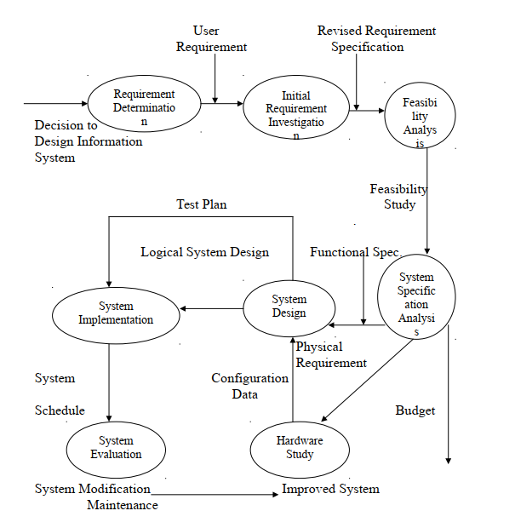

**Fig.1 System Development Life Cycle**

#### Feasibility study

This phase analyzes the feasibility of the project and proposes the business proposal with a very general project plan and some cost estimates. During the analysis of the system, a feasibility study of the proposed system is carried out to ensure that the proposed system does not burden the company. For the feasibility study, it is important to understand the main system requirements. Three key considerations involved in the feasibility analysis are:

**Economic Feasibility**

This is a very important aspect to be considered while developing a project. This study is carried out to examine the economic impact of the system, the amount of funds that the company can invest in research and development of the system is limited, the expenditure must be justified and within budget and this has been achieved because most of the technologies used are freely available. Only customized products need to be purchased.

**Technical Feasibility**

This study is carried out to check the technical feasibility, i.e. the technical requirements of the system. Any system developed should not place high demands on the available technical resources, which means high demands on the customer. The system developed should have a modest requirement, such as minimal or no changes to the implementation of that system.

**Operational Feasibility**

The study aspect is to check the user acceptance of the system, this includes the process of training the user to use the system efficiently, and the user should not feel threatened by the system but accept it as a need. User acceptance depends solely on the methods with which the user is informed and made familiar about the system, his self-confidence must be high so that he can also express constructive criticism, which is welcome, since he is the end user of the system.

**CHAPTER – 4**

**SYSTEM DESIGN**

**Data Flow Diagram**

**DFD Level 0**

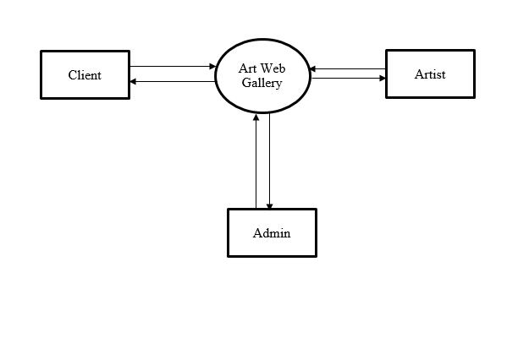

**Fig.2 DFD Level 0**

**DFD Level 1 Client**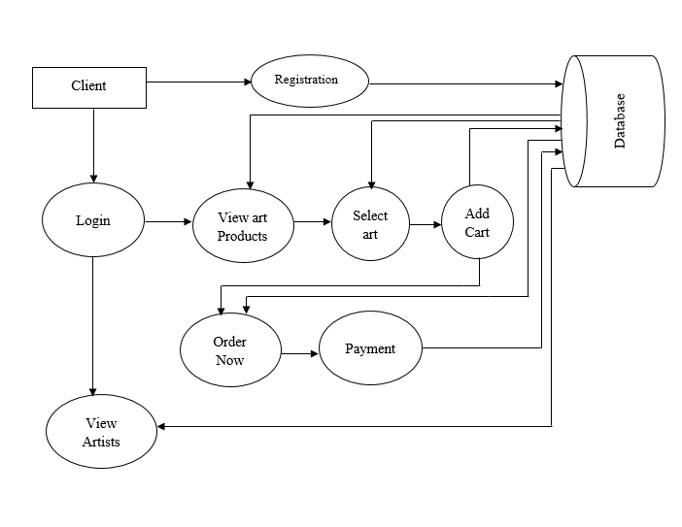

**Fig.3 DFD Level 1 Client**

Database

Artist

**DFD Level 1 Artist**

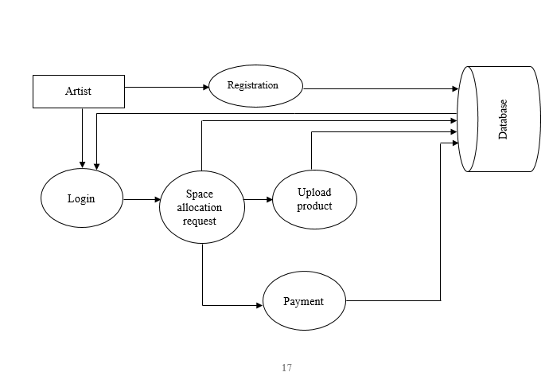

**Fig.4 DFD Level 1 Artist**

**DFD Level 1 Admin**

Artist

Database

Client

Admin

**Fig.4 DFD Level 1 Admin**

**Activity Diagram**

The activity diagram of our project is:

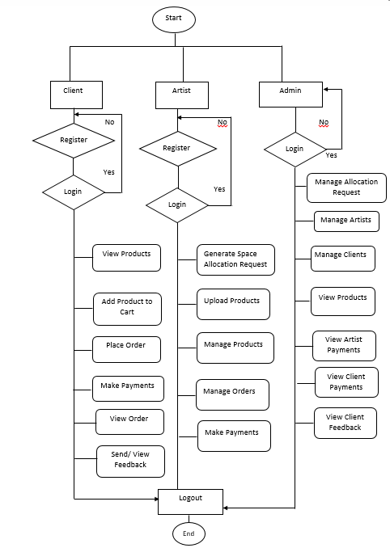

**Fig. 5 Activity Diagram**

**Use Case Diagram**

The use case diagram of our project is:

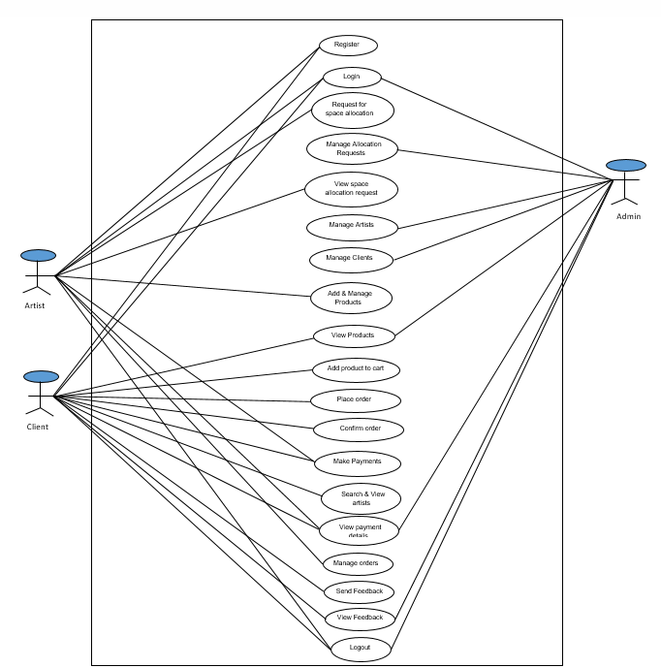

**Fig. 6 Use Case Diagram**

**Sequence Diagram**

The sequence diagram of our project is:

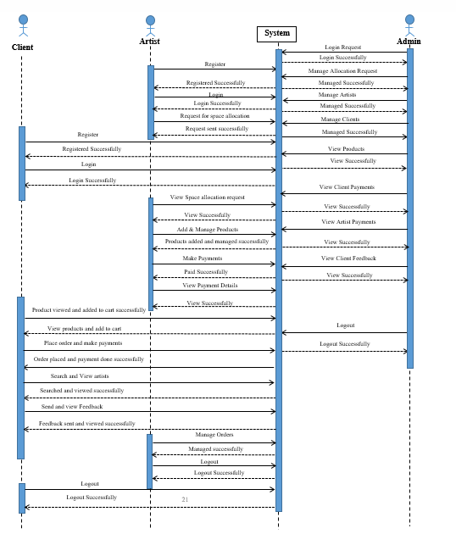

**Fig. 7 Sequence Diagram**

**Interface Diagram**

* Artist can register into the system.

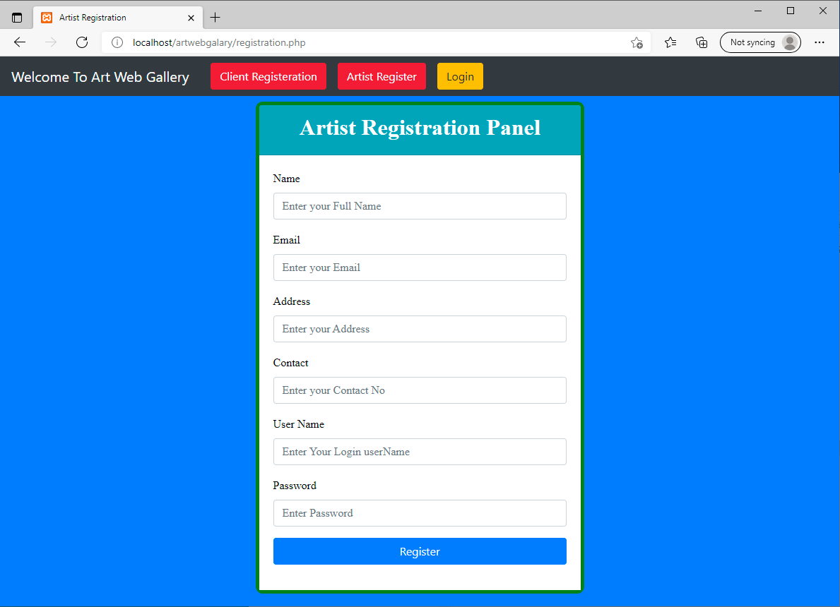

**Fig.8 Artist Registration**

* Client can register into the system.

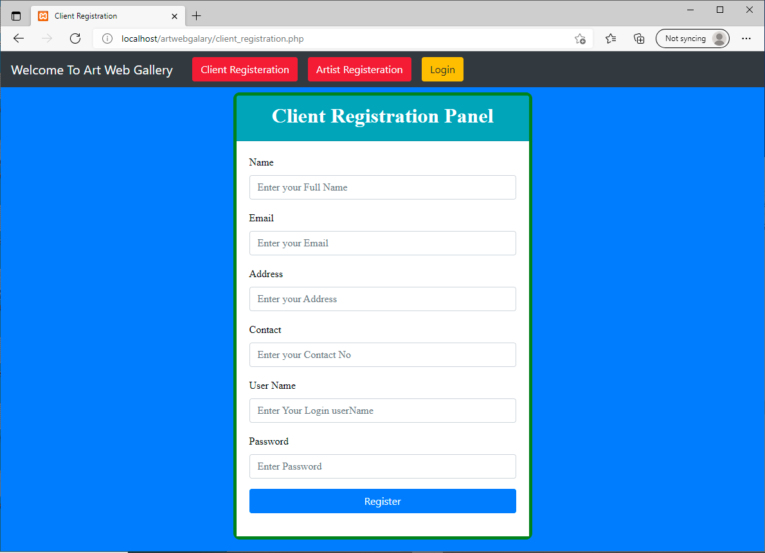

**Fig.9 Client Registration**

* Admin, artist and client can login into the system via email and password.

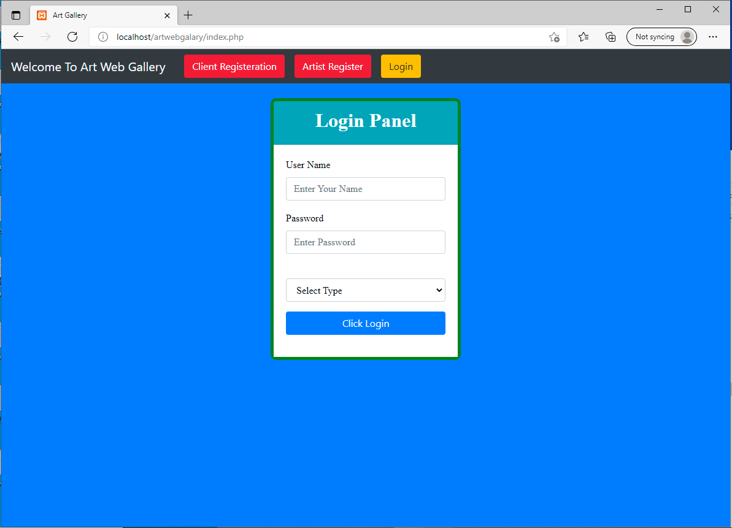

**Fig.10 Login Page**

* When admin login then a dashboard page appears.

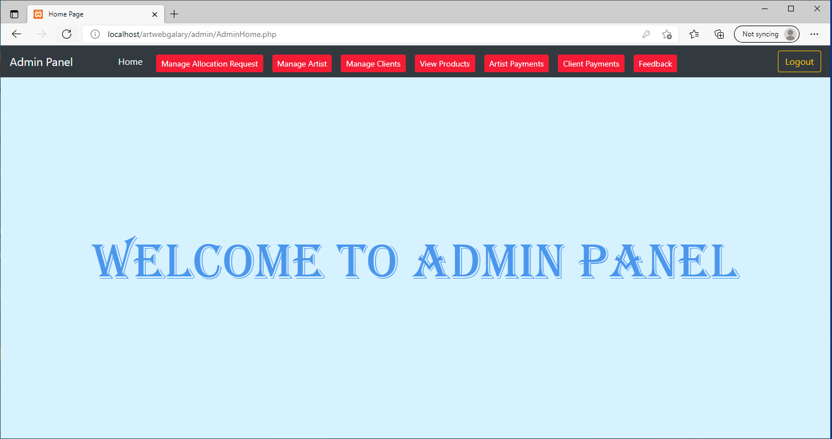

**Fig.11 Admin Home Page**

* Admin can manage allocation requests.

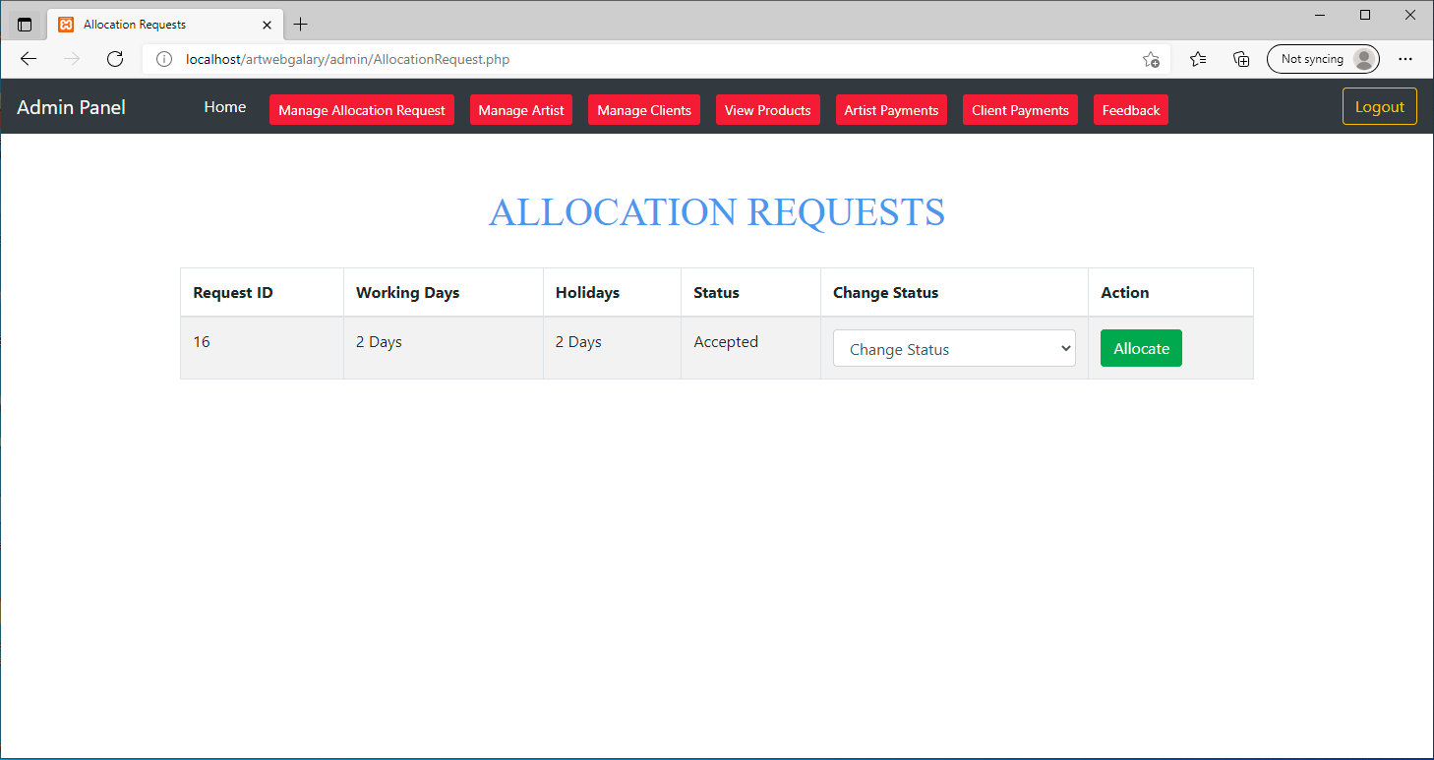

**Fig.12 Manage Allocation Requests**

* Admin can manage artists.

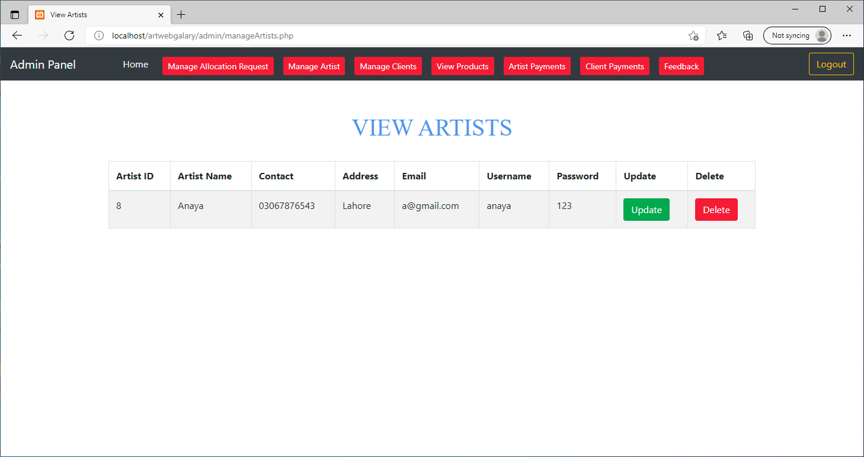

**Fig.13 Manage Artists**

* Admin can manage clients.

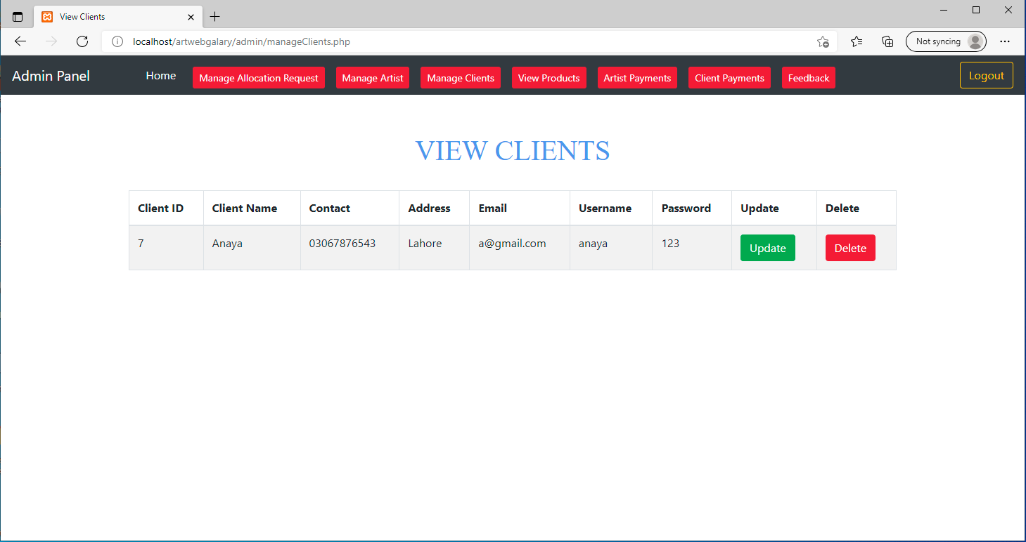

**Fig.14 Manage Clients**

* Admin can view the products uploaded by artist.

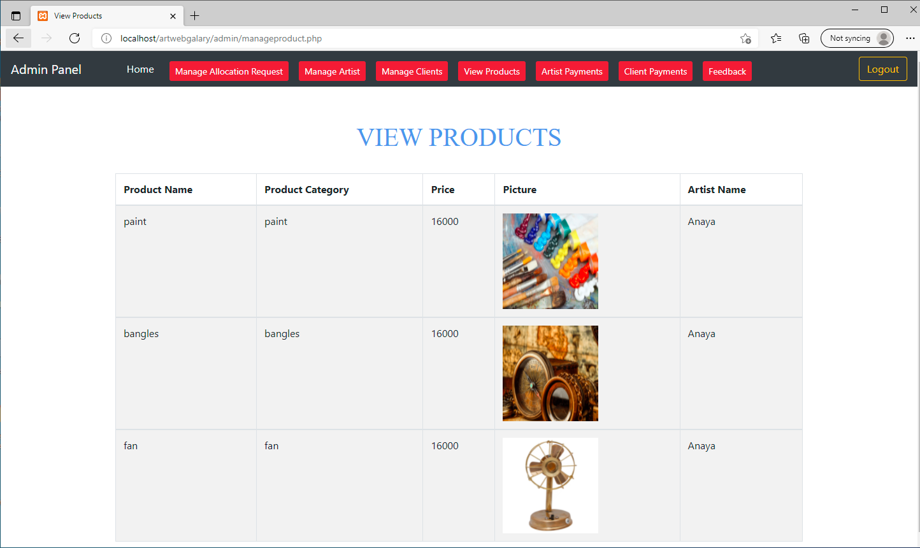

**Fig.15 View Artist Products**

* Admin can view artist payments.

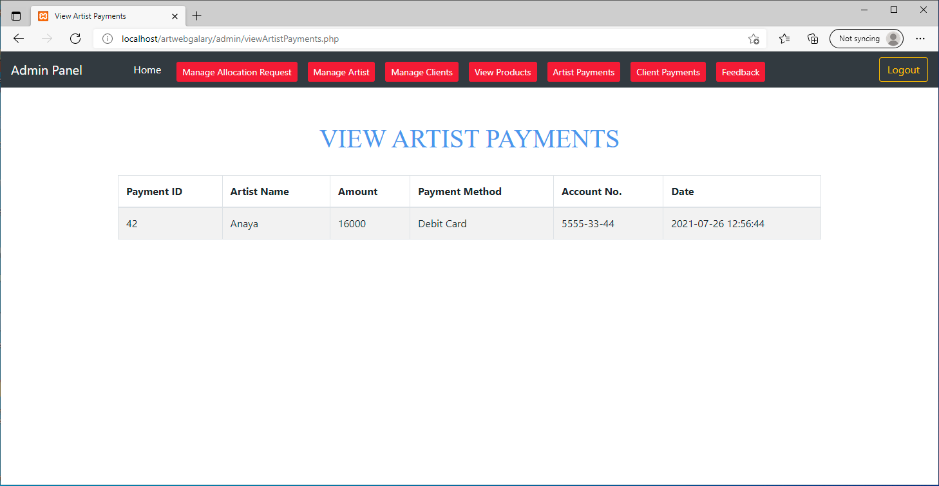

**Fig.16 View Artist Payments**

* Admin can view client payments.

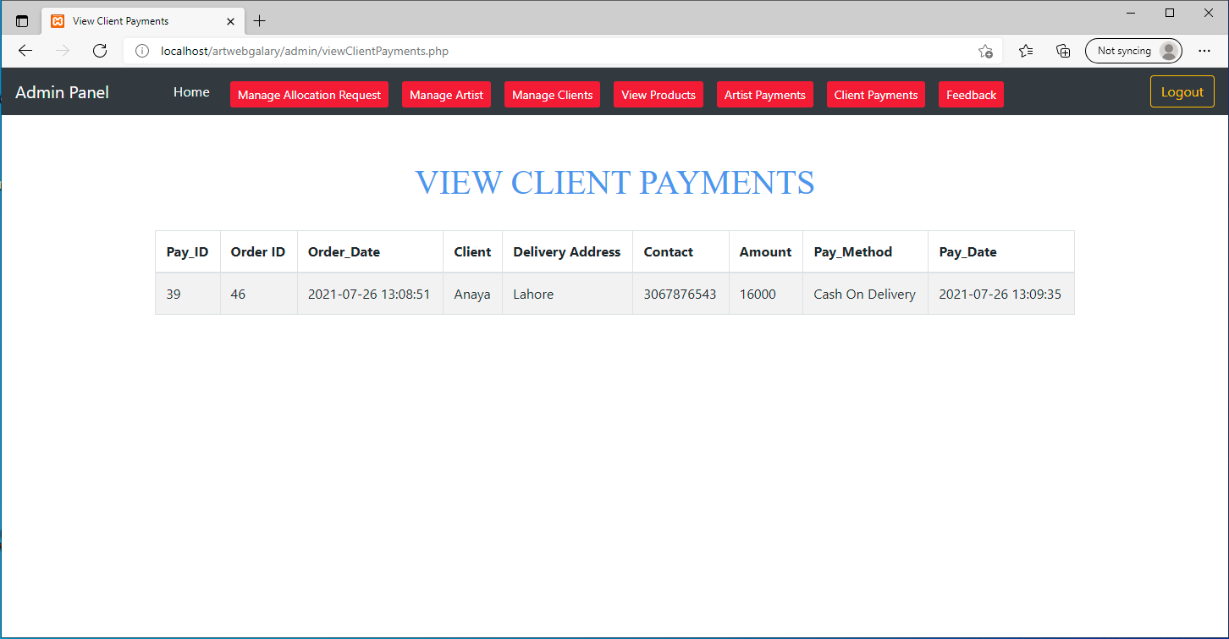

**Fig.17 View Client Payments**

* Admin can view client’s feedback.

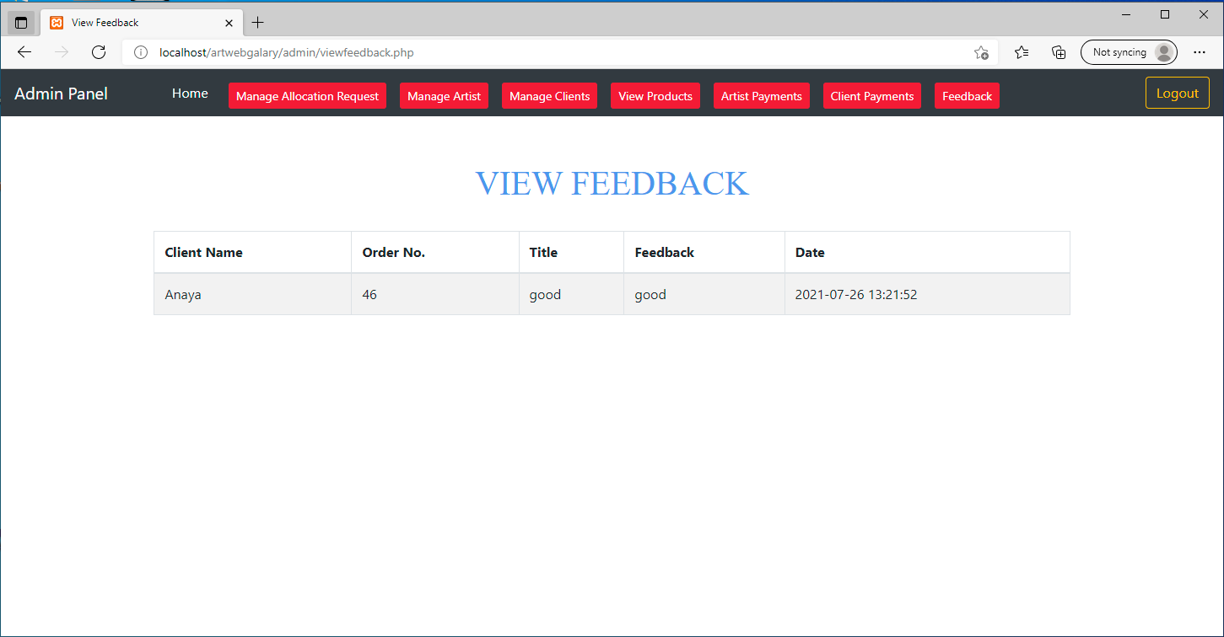

**Fig.18 View Clients Feedback**

* When artist login then a dashboard page appears.

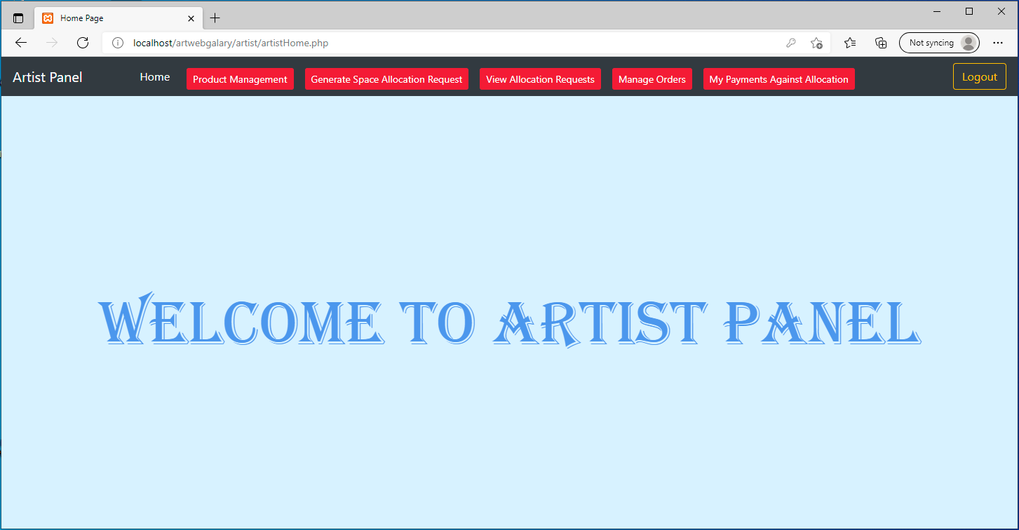

**Fig.19 Artist Home Page**

* Artist can generate space allocation request.

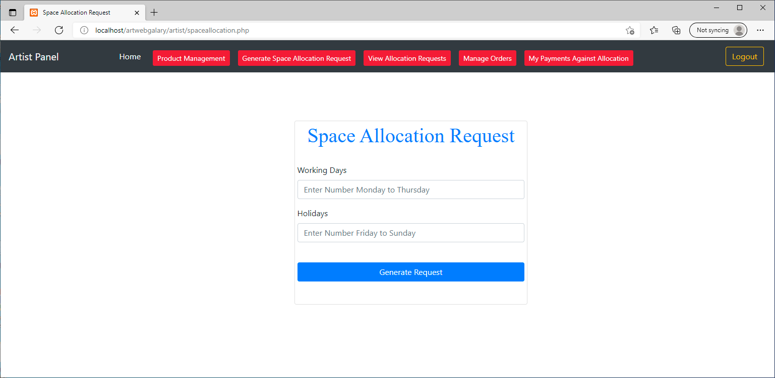

**Fig.20 Space Allocation Request**

* Artist can view the space allocation request.

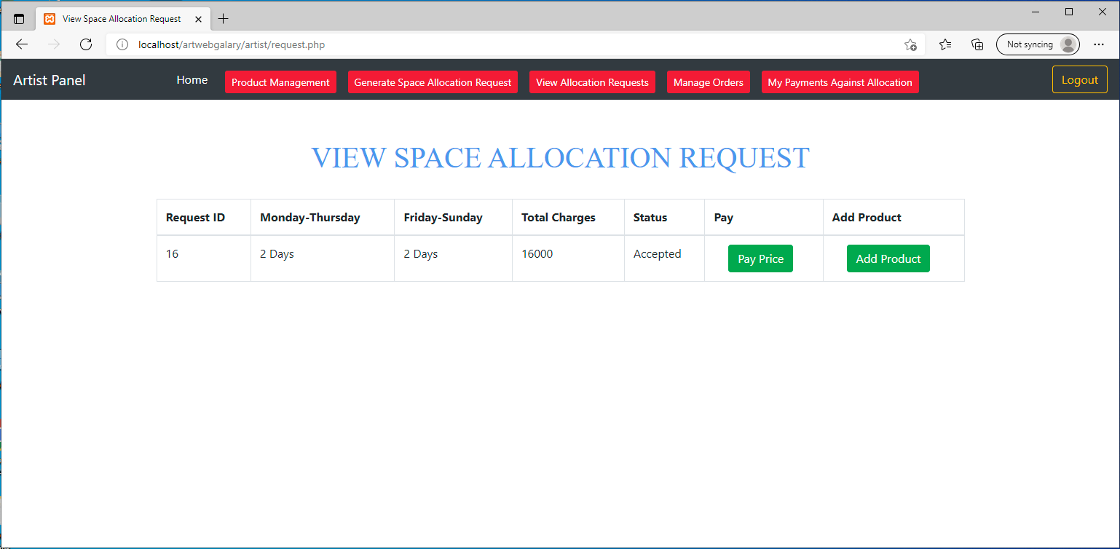

**Fig.21 View Space Allocation Request**

* Artist can upload the products.

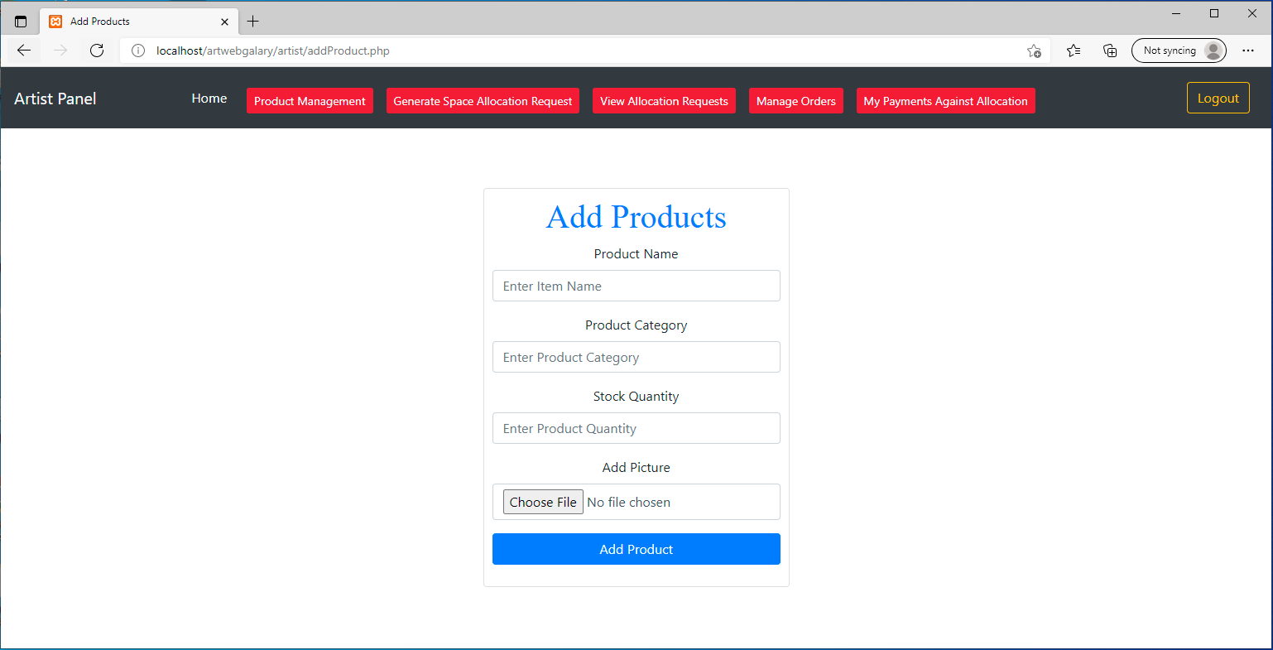

**Fig.22 Upload Products**

* Artist can manage the products.

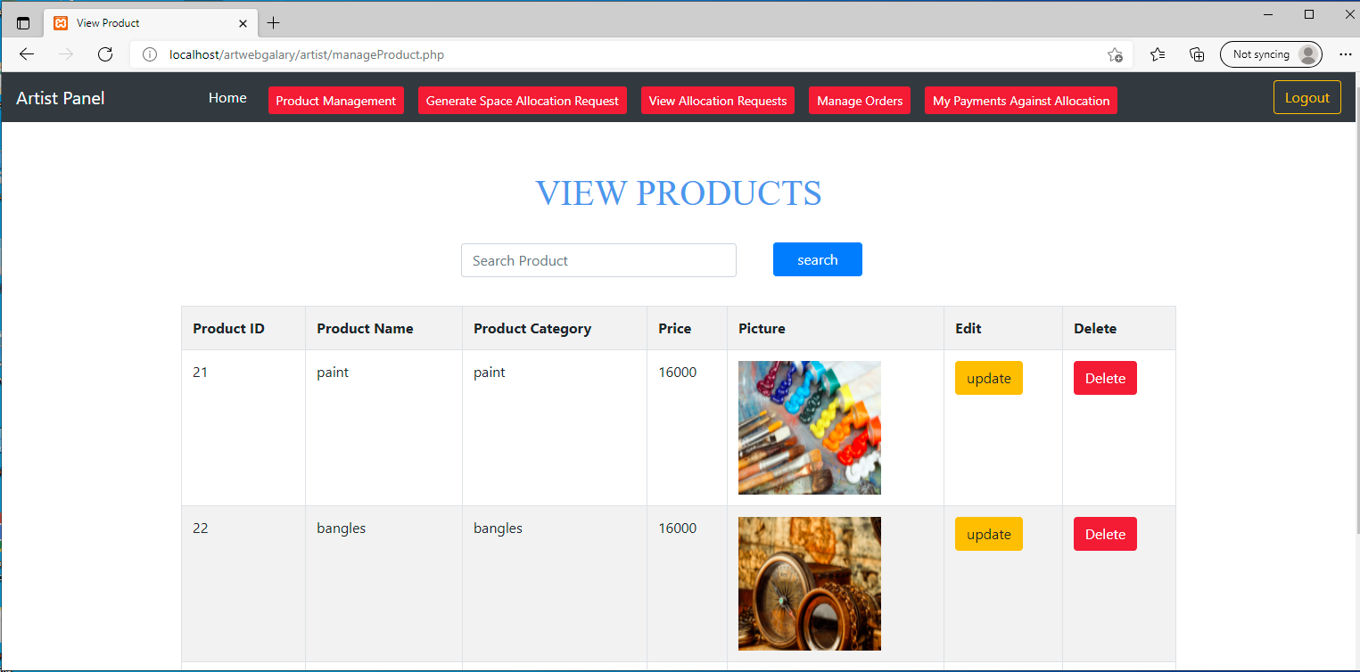

**Fig.23 Manage Products**

* Artist can make payments.

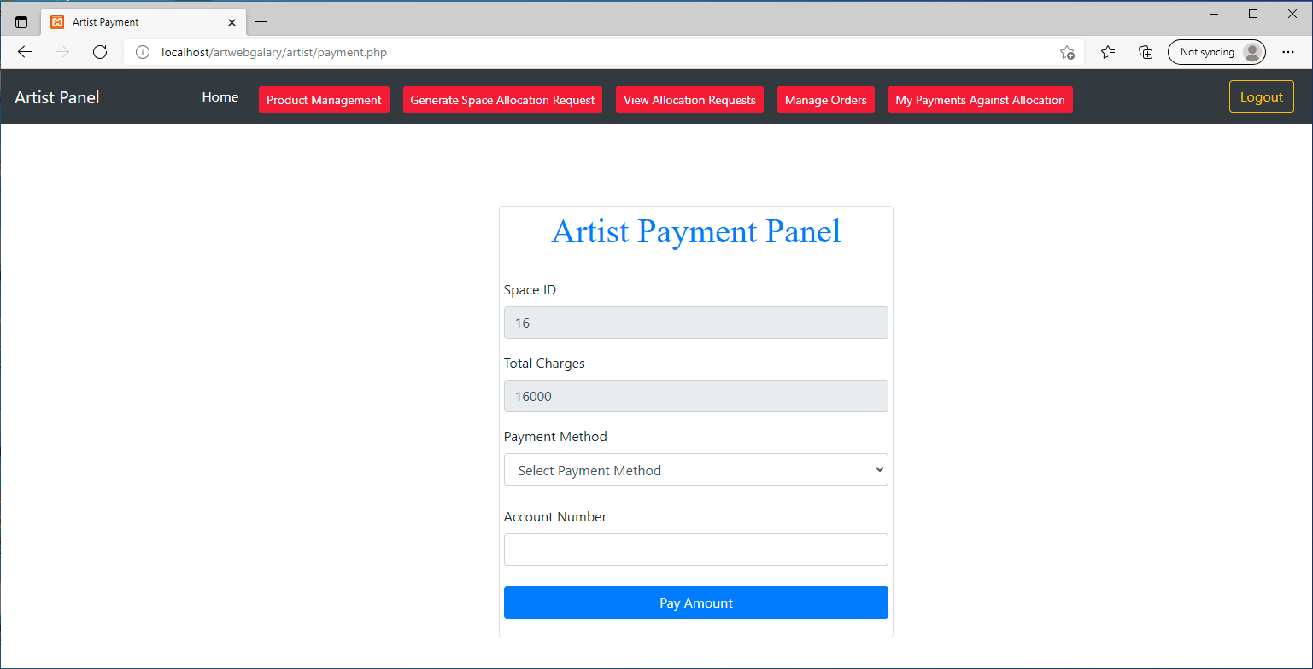

**Fig.24 Artist Make Payment**

* Artist can view the payment details.

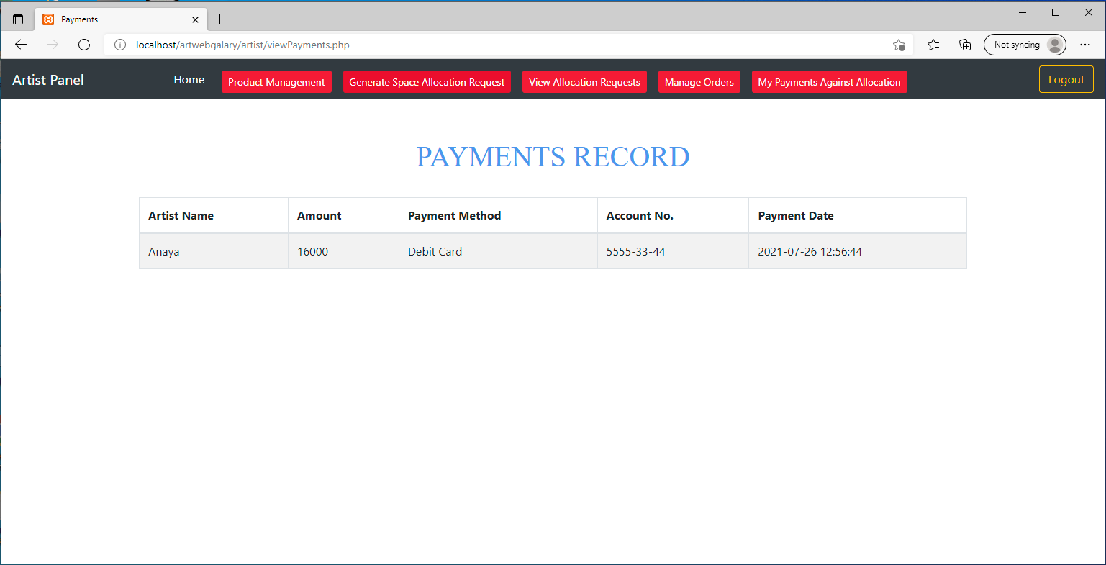

**Fig.25 Artist View Payments**

* Artist can manage orders.

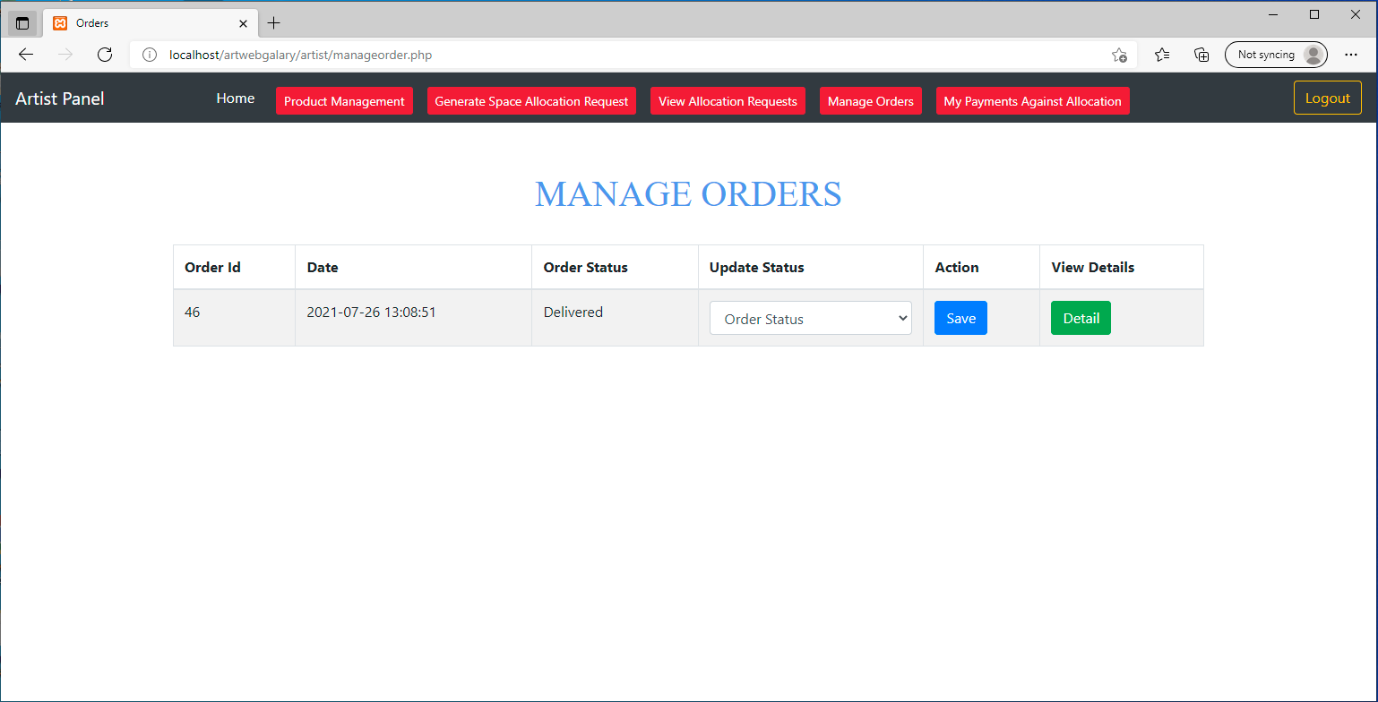

**Fig.26 Manage orders**

* When a client login, then a dashboard page appears which contains the product details.

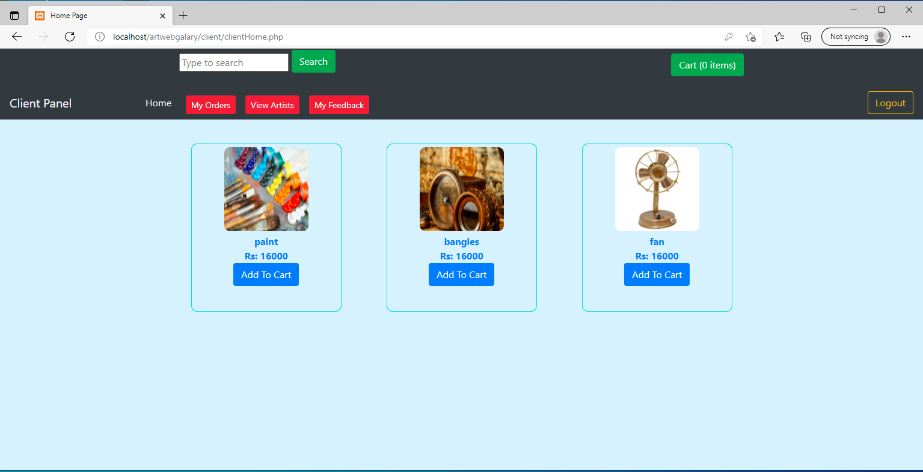

**Fig.27 Client view Products**

* Client can add product to cart and confirm an order.

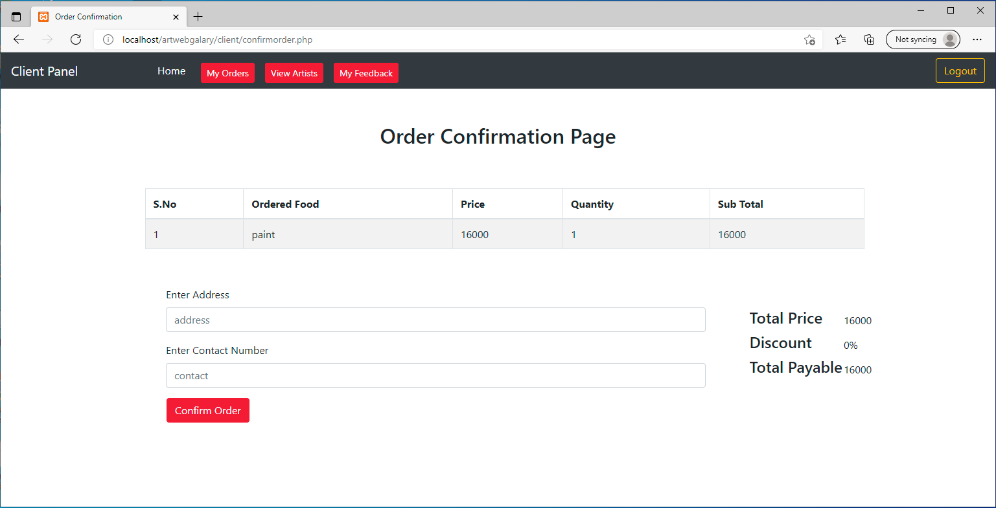

**Fig.28 Order Confirmation Page**

* Client can make payments.

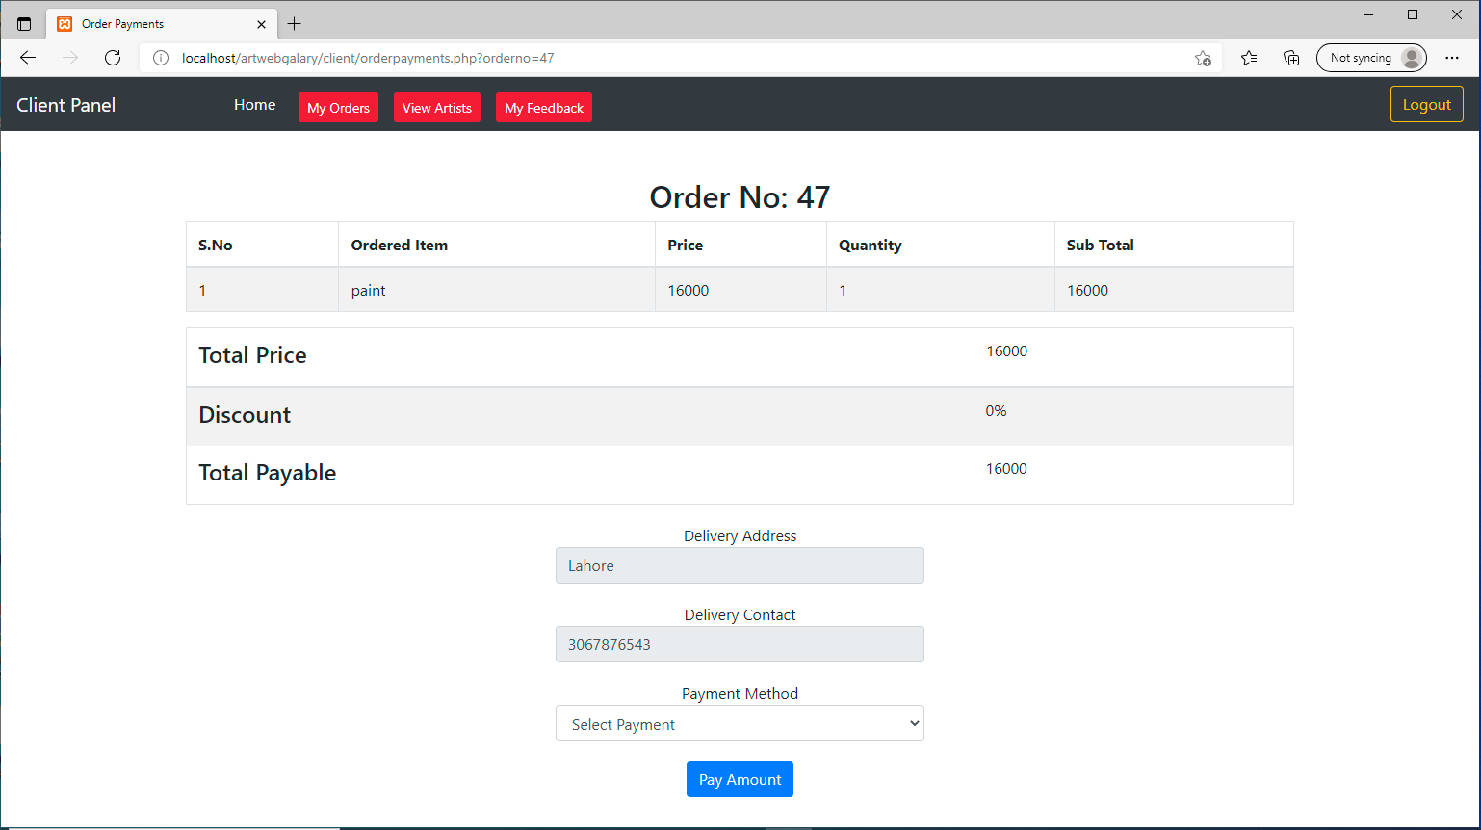

**Fig.29 Client Make Payments**

* Client can search and view the artists.

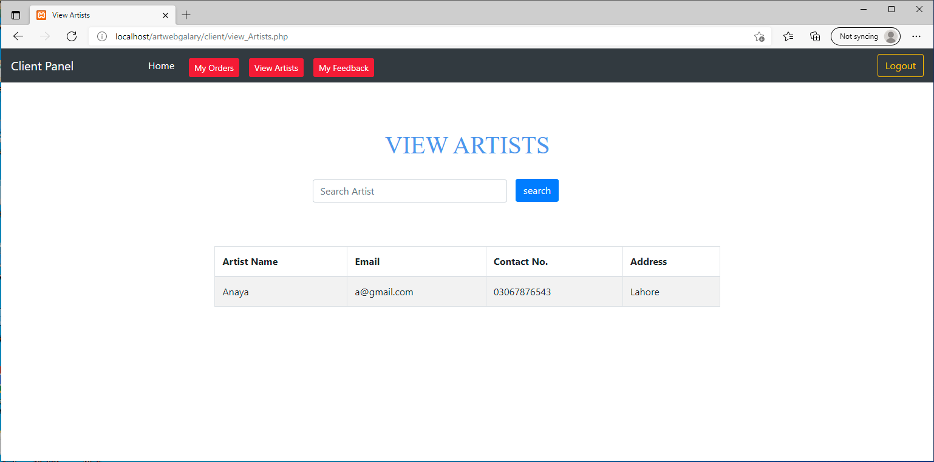

**Fig.30 View artists**

* Client can send feedback.

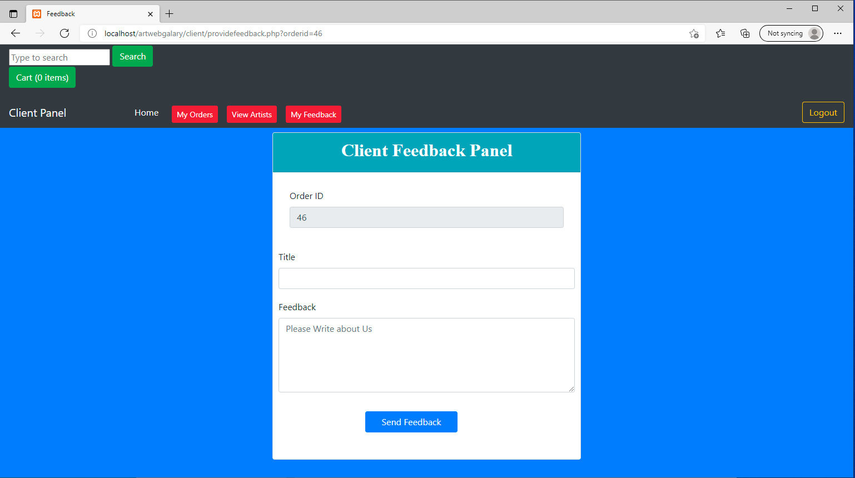

**Fig.31 Send Feedback**

* Client can view the feedback.

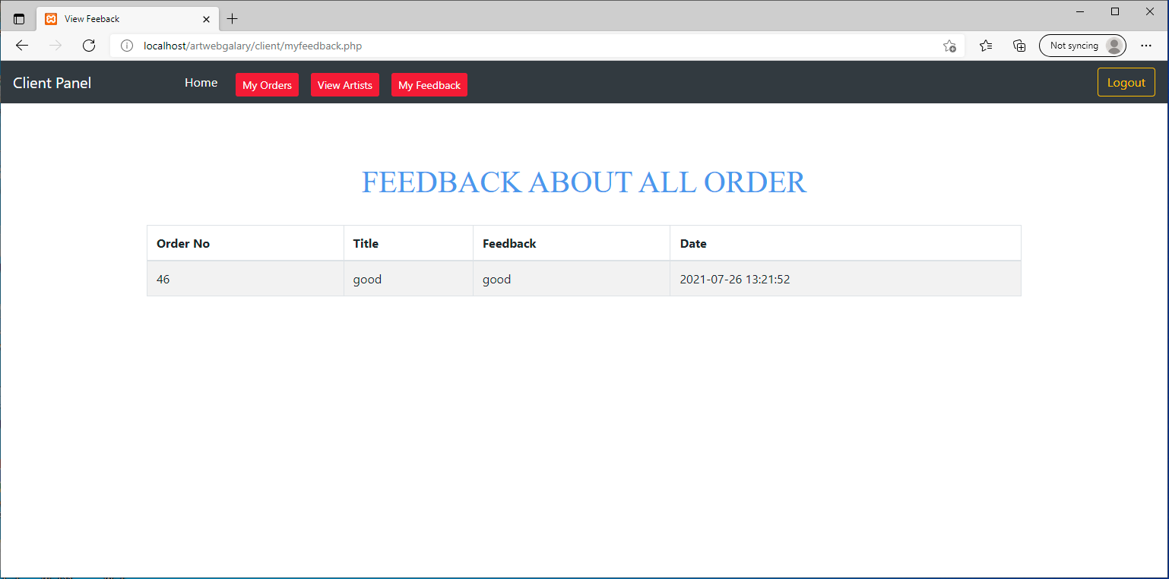

**Fig.32 View Feedback**

**Conclusion**

The computation of “art web gallery” has been developed by us through applying our knowledge referring to certain images, browsing some sites and through the help of external and internal faculties and using our own knowledge related to the subject itself.

The system has been made so transparent for the users so that client can trust and have faith in reliability of information. Our system is users friendly and users will be satisfied with the system.

No project can be teamed as “perfect” in real sense and there always remains scope for further improvement and so that helps to develop a new version. We are always eager to know some new points and validation related to the projects and which give us more knowledge and help us to create new version.

**References**

1. Health Information System Strategic Plan; Republic of Kenya; Health Sector  
   Strategic Plan for Health Information System, 2009-2014, 1.
2. Health Information System, Republic of Kenya, Ministry of Health, Health sector;  
   Health information system policy, 2008.
3. R. Haux, W. Alfred, “Strategic Information Management in Hospitals: New York: Springer,” 2004.
4. G. Finchman, et al, Editorial Overview – “The role of IS in Healthcare. Information Systems Research,” 2011, Vol. 22, p. 421.
5. J. Cruicksack, P. Carl, and P. Jon, “Personal Health Records: Putting Patients in  
   control,” 2012.
6. World Health Organization. The World Health Report. *World Health  
   Organization* World Health Organization 2008: Framework and standards for  
   country health information systems, 2nd edition. Geneva: World Health  
   Organization, 2013.
7. Musa, A. Lancashire Bus. Sch., Univ. of Central Lancashire, Preston, UK Yusuf, Y, Meckel.M., “A hospital resource and patient management system based on real-time data capture and intelligent decision making” Univ. of Central Lancashire, Preston, UK Yusuf, Y, Meckel.M. Systems and Informatics (ICSAI), 2012 International Conference
8. D. Hu, Antai Sch. of Manage., Shanghai Jiaotong Univ., China W. Xu ; H. Shen ; Li. Mengyu, “Study on information system of health care services management in hospital,” Services Systems and Services Management, 2005. Proceedings of ICSSSM '05. 2005 International Conference
9. G. Hübner-Blodera, E. Ammenwertha , B. Brigl , A. Winter, “Specification of a Reference Model for the Domain Layer of a Hospital Information System,” Institute for Health Information Systems,UMIT – University for Health Sciences, Medical Informatics and Technology, Hall in Tyrol, Austria b Institute for Medical Informatics, Statistics and Epidemiology, University of Leipzig, Germany, ENMI, 2005

C. Bain, “Developing Effective Hospital Management Information Systems: A Technology Ecosystem Perspective,” 20